Week 6

Aim: To Solve binomial and poisson problems and visualizing PMF and CDF.

Commands Used:
- Dbinom = find the PMF of binomial
- Pbinom = find the CDF of binomial
- Ppois = find the poisson prob with a given lambda
- Dpois = find the continuous poisson prob with a given lambda

Questions:

- For a random variable X with a binomial (20,1/2) distribution .Find the following

- Find Pr(X<8)
- Find Pr(X>12)
- Find Pr(8<=X<=12)
- Plot PMF and CDF

Sol 1:
> a=sum(dbinom(0:7,20,0.5))
> b=sum(dbinom(13:20,20,0.5))
> c=sum(dbinom(8:12,20,0.5))
> a
[1] 0.131588
> b
[1] 0.131588
> c
[1] 0.736824
plot((0:20),dbinom(0:20,20,0.5),col=3,type="h",main="PMF of binomial (20,1/2)",xlab="x",ylab="P(x)")
plot((0:20),pbinom(0:20,20,0.5),col=4,type="h",main="CDF of binomial (20,1/2)",xlab="x",ylab="P(x)") 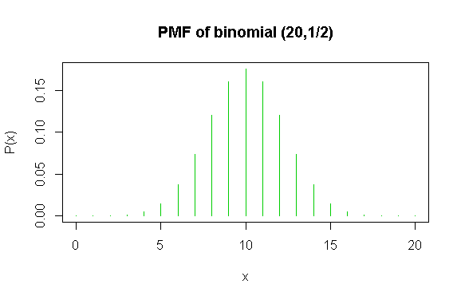

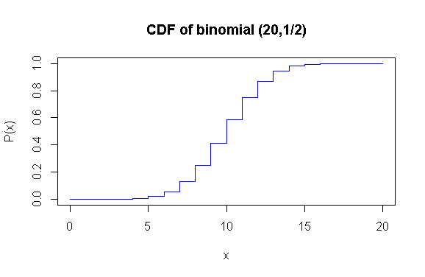
~~~~~~~~~~~~~~~~~~~~~~~~~~~~~~~~~~~~~~~~~~~~~~~~~~~~~~~~~~~~~~~~~~~~~~~

2. For a binomial (200,1/2) distribution

  - Find Pr(X<80)
  - Find Pr(X>120)
  - Find Pr(80<=X<=120)
  - Plot PMF and CDF

Sol 2:
> a=sum(dbinom(0:79,200,0.5))
> b=sum(dbinom(121:200,200,0.5))
> c=sum(dbinom(80:120,200,0.5))
> a
[1] 0.001817474
> b
[1] 0.001817474
> c
[1] 0.9963651
plot((0:200),dbinom(0:200,200,0.5),col=3,type="h",main="PMF of binomial (200,1/2)",xlab="x",ylab="P(x)")
plot((0:200),pbinom(0:200,200,0.5),col=4,type="h",main="CDF of binomial (200,1/2)",xlab="x",ylab="P(x)")

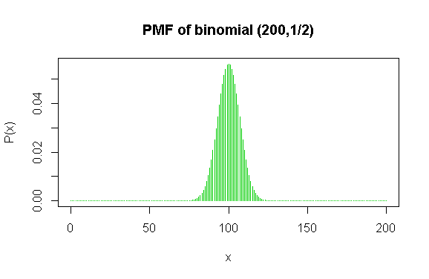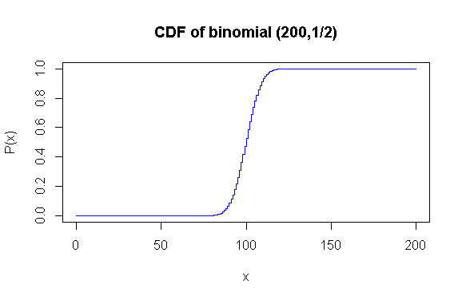
~~~~~~~~~~~~~~~~~~~~~~~~~~~~~~~~~~~~~~~~~~~~~~~~~~~~~~~~~~~~~~~~~~

3. Suppose one random variable X is Poisson with lambda=12.33

- What is the Probability of 15 or fewer occurrences? P(X<=15)
- What is the Probability of 6 occurrences? P(X=6)
- What is the Probability of more than 15 occurrences? P(X>15)
- What is the Probability of more than 14 occurrences? P(X>=15)
- What is the Probability of al least 8 and at most 10 occurrences? P(8<=X<=10)

Sol 5:
> ppois(15,lambda=12.33)
[1] 0.8195608
> dpois(6,lambda=12.33)
[1] 0.02155733
> 1-ppois(15,lambda=12.33)
[1] 0.1804392
> 1-ppois(14,lambda=12.33)
[1] 0.2586192
> ppois(10,lambda=12.33)-ppois(7,lambda=12.33)
[1] 0.2375607

- The number of traffic accidents that occur on a particular stretch of road during a month follows a poisson distribution with a mean of 7.6. Draw the PMF and CDF.
Sol.
sum(dpois(0:2,lambda = 7.6))
ppois(2,lambda = 7.6)
DD=0:15
PP=dpois(DD,7.6)
sum(PP)
plot(DD,PP,type="h",col=2,main="Pmf of Poisson",xlab="x axis",ylab="P(x)")
points(DD,PP,col=3);
abline(h=0,col=4)
xp=seq(0,15,0.01)
plot(xp,ppois(xp,lambda = 7.6),col=10,type="s",main="CDf of Poisson",xlab="x axis",ylab="F(x)")

Plot:
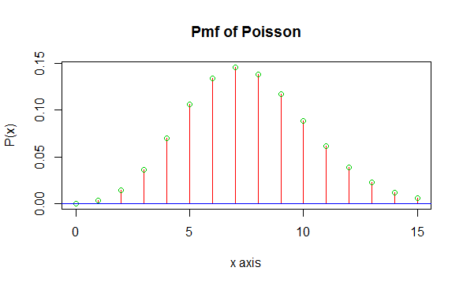

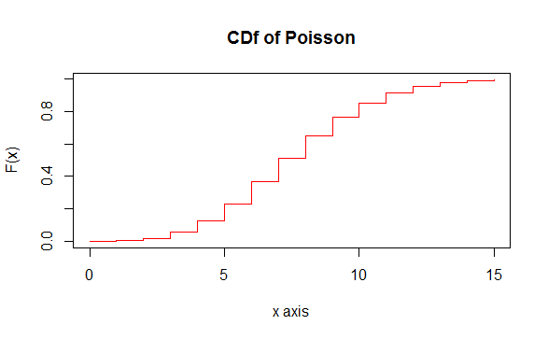

Result:
The PMF and CDF for the given problems were successfully implemented.

